**1)Write a query to insert a new employee into the Employees table with values (1, 'John', 'HR', 50000).**

CREATE TABLE Employees (ID INT PRIMARY KEY, Name VARCHAR(50),Department

VARCHAR(50),Salary INT);

INSERT INTO Employees (ID, Name, Department, Salary)

VALUES (1, 'John', 'HR', 50000);

SELECT * FROM Employees;

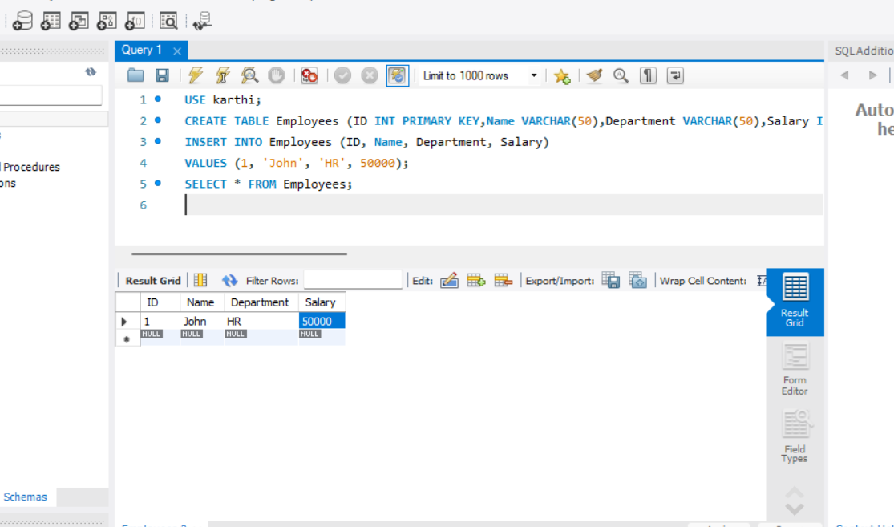

**2) Write a query to insert multiple rows into a table in a single query.**

INSERT INTO Employees (ID, Name, Department, Salary)

VALUES

(2, 'Alice', 'IT', 60000),

(3, 'Bob', 'Finance', 55000),

(4, 'Charlie', 'Sales', 45000);

SELECT * FROM Employees;

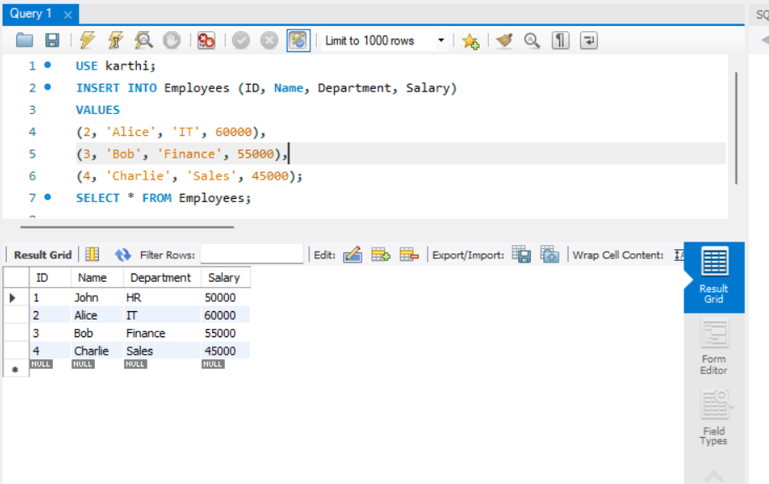

**3. Write an INSERT query where only some columns are provided (not all).**

INSERT INTO Employees (ID, Name)

VALUES (5, 'David');

SELECT * FROM Employees;

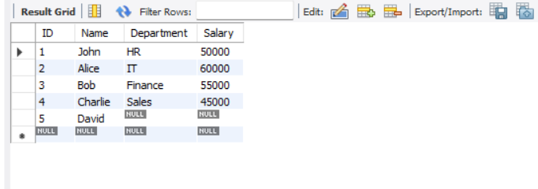

**4. Write a query to update the salary of an employee with ID = 101 to 60000.**

UPDATE Employees

SET Salary = 60000

WHERE ID = 101;

SELECT * FROM Employees;

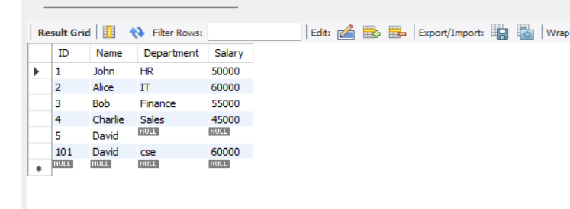

**5. Update the department of all employees from 'Sales' to 'Marketing'.**

UPDATE Employees

SET Department = 'Marketing'

WHERE Department = 'Sales'

SELECT * FROM Employees;

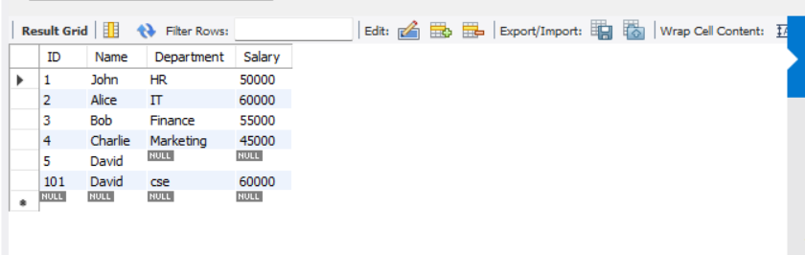

**6. Increase salary by 10% for all employees in the 'IT' department.**

UPDATE Employees

SET Salary = Salary * 1.10

WHERE Department = 'IT';

SELECT * FROM Employees;

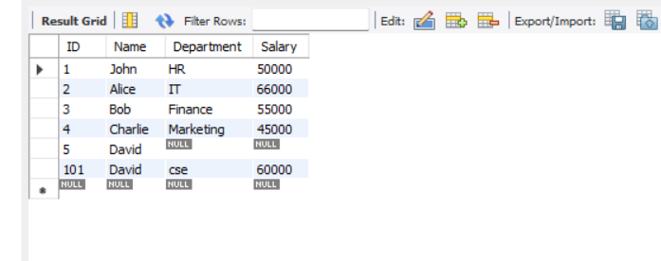

**7. Write a query to update multiple columns in a table using a single statement.**

UPDATE Employees

SET Name = 'John Smith',

Salary = 65000

WHERE ID = 101;

SELECT * FROM Employees;

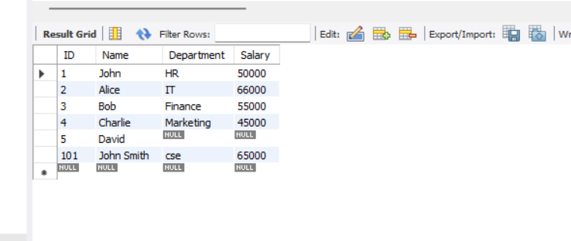

**8. Write a query to delete a record from the Employees table where ID = 5.**

DELETE FROM Employees

WHERE ID = 5;

SELECT * FROM Employees;

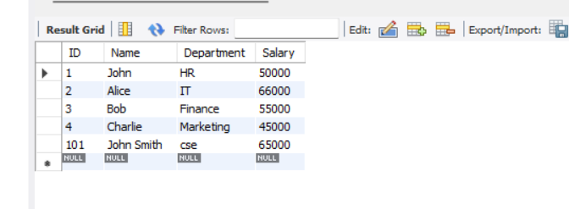

**9. Delete all employees whose department is 'HR'.**

DELETE FROM Employees

WHERE Department = 'HR';

SELECT * FROM Employees;

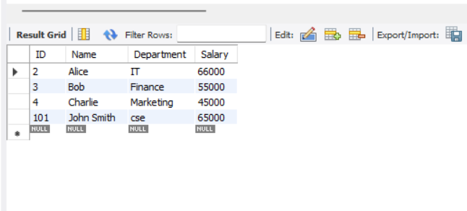

**10. Delete all records from a table but keep the structure.**

DELETE FROM Employees;

SELECT * FROM Employees;

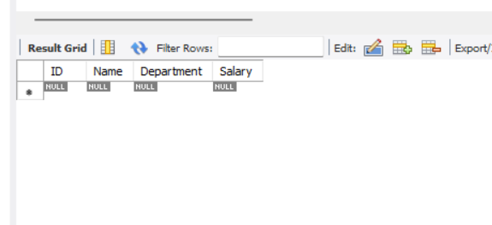

11. Write a delete query using a subquery to delete specific rows.

12. Write a query to create a table called Students with columns: ID, Name, Age, and Email.

CREATE TABLE Students (

ID INT PRIMARY KEY,

Name VARCHAR(50),

Age INT,

Email VARCHAR(100)

);

SELECT * FROM Students;

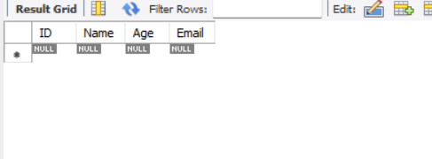

13. Create a table Orders with a foreign key referencing the Customers table.

14. Write a query to create a table with a unique constraint on the email column.

**15. Create a table and set the default value of the status column to 'Active'.**

CREATE TABLE Tasks (

TaskID INT PRIMARY KEY,

TaskName VARCHAR(100),

Status VARCHAR(20) DEFAULT 'Active'

);

**16. Create a table with a primary key on multiple columns.**

CREATE TABLE Enrollment (

StudentID INT,

CourseID INT,

EnrollmentDate DATE,

PRIMARY KEY (StudentID, CourseID)

);

SELECT * FROM Enrollment;

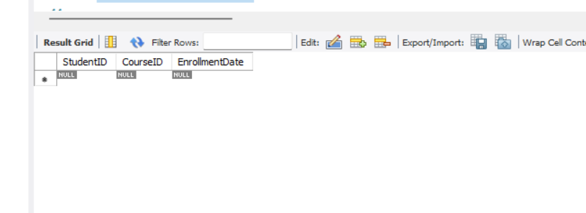

**17. Write a query to drop a table named TempData.**

DROP TABLE TempData;

18. Drop only the primary key constraint from a table.

**19. Write a query to drop a column from an existing table.**

ALTER TABLE Enrollment

DROP COLUMN EnrollmentDate;

SELECT * FROM Enrollment;

**20. Drop all indexes on a given table.**

ALTER TABLE Employees

DROP PRIMARY KEY;

**21. Write a query to add a new column DOB of type DATE to the Employees table**.

ALTER TABLE Employees

ADD DOB DATE;

select*from Employees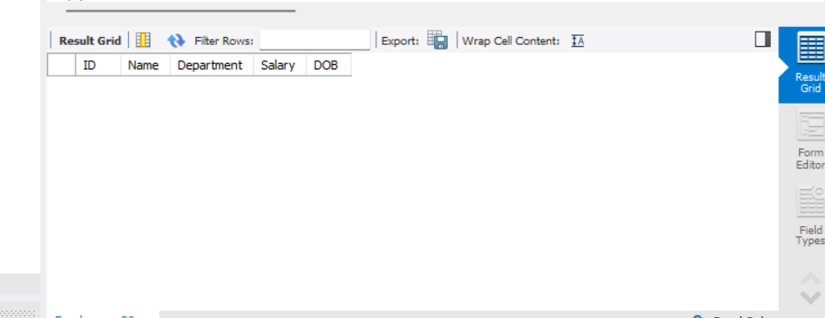

**22. Modify the data type of the column Salary from INT to FLOAT.**

ALTER TABLE Employees

MODIFY Salary FLOAT;

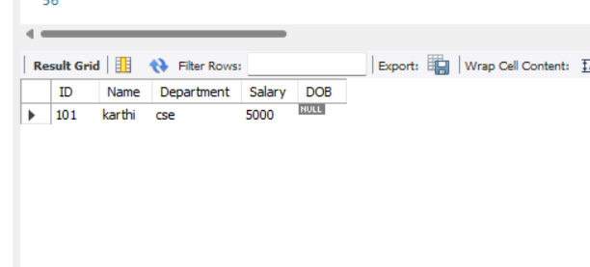

**23. Rename a column in a table from fullname to name.**

ALTER TABLE Employees

RENAME COLUMN name TO fullname;

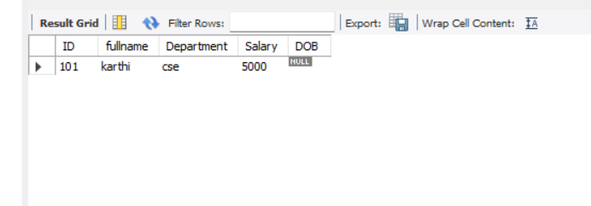

**24. Rename the table Customers to Clients.**

RENAME TABLE Customers TO Clients;

**25. Add a NOT NULL constraint to the email column in the Users table.**

**26. Truncate a table and insert one row back using INSERT.**

TRUNCATE TABLE Employees;

INSERT INTO Employees (ID, Name, Department, Salary)

VALUES (1, 'John', 'HR', 50000);

SELECT * FROM Employees;

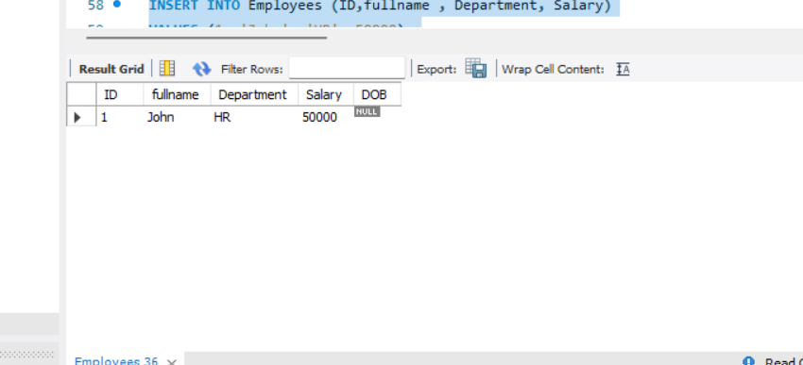

**27. Truncate multiple tables in one transaction (if supported).**

START TRANSACTION;

TRUNCATE TABLE Employees;

TRUNCATE TABLE Students;

COMMIT;

